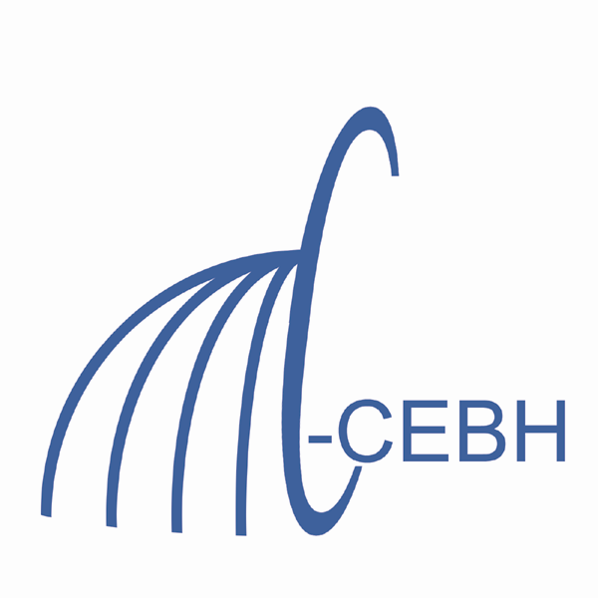

COMPARATIVE AND EVOLUTIONARY BIOLOGY OF HEARING

TRAINING PROGRAM PREDOCTORAL FELLOWSHIP APPLICATION
♦ Submit application and all materials as a single PDF (as described below) to Dr. Joo Jun, cebh@umd.edu
♦ Training starts July 1 of each year and lasts for one year. Complete applications must be received no later than March 15th of each year for participation in the program starting the following July 1. (It is recommended that potential applicants contact CEBH to get the “closing” date for applications each year).
NOTE: By law, only U. S. citizens or permanent residents (green card holders) may be supported by this training grant. Partial year support cannot be provided.

Name: ________________________________________________________________________

Current address: ________________________________________________________________

______________________________________________________________________________

Phone: _______________________ FAX: ____________________ E-MAIL: ____________

Are you already in a doctoral program that will be continued as a trainee? _________

If so, answer following questions about your current advisors and dissertation work:

(Proposed) Major Professor: ____________________ Co-advisor: __________________

Have you contacted these advisors?______________ When?________________________

Undergraduate GPA:________________ Undergraduate degree: _____________________

GRE Scores: Verbal:_______ Quantitative: _______

Undergraduate school and department: _________________________________________

Date of MS or other degree: _____________ Type of degree: ___________

Graduate School: ______________________ Graduate department: __________________

Major professor: _______________________

Additional Material

New Students to the Training Program – NOTE please email the complete file, as one PDF, to Dr. Joo Jun. The file should contain:

1. The application form filled in
2. A complete updated CV
3. In a paragraph or two, describe your career goals beyond the doctoral program
4. Up to a page describing your research interest and the research you expect to do for your doctorate in our program.
5. An abstract of any research you have done
6. Any additional information that you think will be helpful in our making a decision
7. PDF’s of any papers you have published (up to two)
8. Letters of recommendation sent directly (as PDFs) to Dr. Joo Jun at cebh@umd.edu
- Have a letter of recommendation from your doctoral advisor
- Have 1-2 other(s)

Current Students – NOTE please email the complete file, as one PDF, to Dr. Joo Jun, cebh@umd.edu. The file should contain:

1. The application form filled in
2. A page or two describing your current research program and your progress to date. Also provide a time-line for completion of your doctorate.
3. A complete updated CV
4. Any additional information that you think will be helpful in our making a decision
5. A listing of grades in courses while you have been supported by the training program
6. A copy of any papers you have published at UM, and especially from training grant work
7. A copy of proposal(s) you have submitted to obtain your own support for your stipend and/or research

In addition: Please have your CEBH advisor send a PDF to cebh@umd.edu with a letter discussing your progress. Letter should indicate that the mentor would like you to continue on the training grant and if (s)he has funds to support you if you are not given an additional year.

